# Dead-Time and LC filter calculations

Figure Reference paper

# Outputs

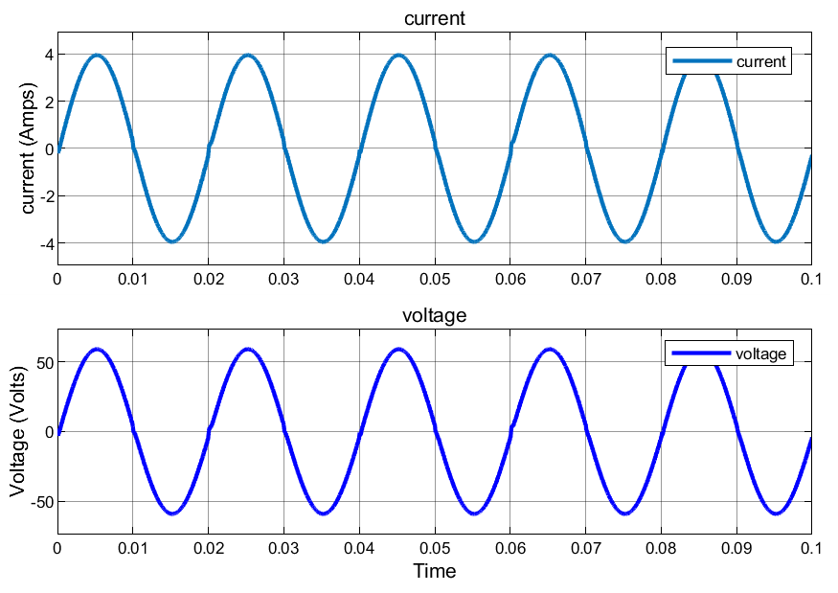

# THD



Figure with 0.8e-6 sec deadTime



Figure with 45.8e-6 sec deadtime



Figure with no deadTime

# References

[1] Azri, M., Rahim, N.A., 2011. Design analysis of low-pass passive filter in single-phase grid-connected transformerless inverter, in: .. doi:10.1109/cet.2011.6041489